**BRIGHTON**

**Saturday 28th June – 2 DAYS, ONE NIGHT**

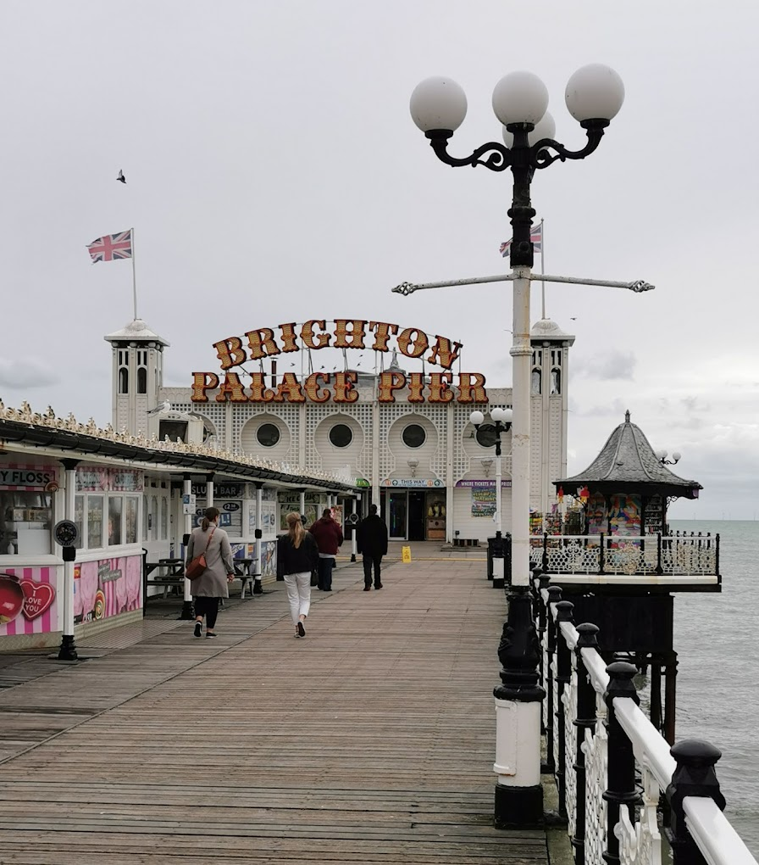

**Cost: Members: £109 and Non-Members: £139**

**SINGLE SUPPLEMENT £75**

**WHAT’S INCLUDED:**

**EXECUTIVE COACH THROUGHOUT**

**ONE NIGHTS ACCOMODATION AT THE CENTRALLY LOCATED 4* LEONARDO HOTEL BRIGHTON HOTEL**

**BREAKFAST**

**ROOMS HAVE WI-FI, A FLAT SCREEN TV, TEA AND COFFEE FACILITIES**

**4* Leonardo Brighton Hotel**

**(**[**www.leonardo-hotels.Com/brighton**](http://www.leonardo-hotels.Com/brighton)

**Nestled in Brighton’s vibrant New England Quarter**

**PLEASE REGISTER YOUR INTEREST BY FRIDAY 7TH MARCH by emailing** [**social_club@bathnes.gov.uk**](mailto:social_club@bathnes.gov.uk)

**Pick up times TBC**